Wyre Forest School Curriculum & Progression Handbook

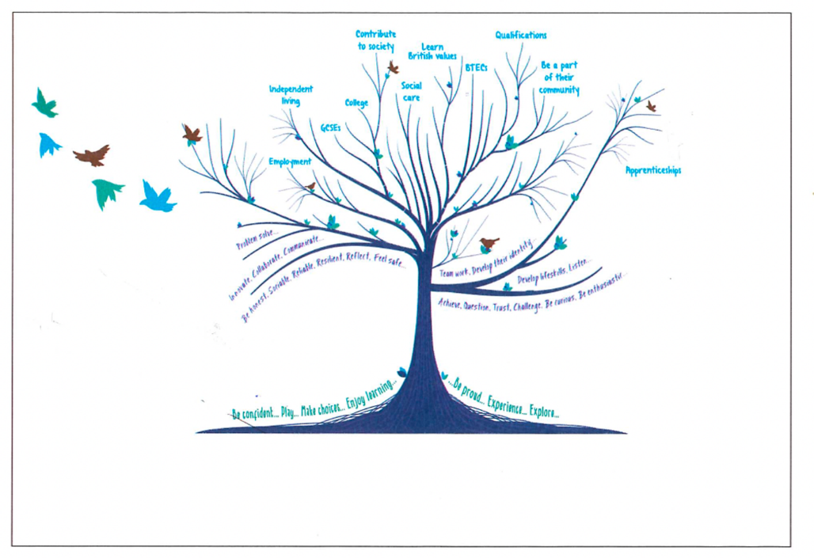

Our Curriculum & Progression Story….

As our learner group changed over the last few years, we recognised that our curriculum offer was no longer appropriate. We were determined to create a curriculum that matched the needs of our learners. To support this, we considered current levels of attainment, staff beliefs and parent/carer views around areas for development for the pupils. We also researched the curriculum offer from other special schools and reputable SEND advisors e.g. Peter Imray & Equals.

We felt that a primary and secondary organisational model, no longer met need. Based upon pupils’ age-related working levels, we created a pathway approach. This now provides a curriculum offer individualised to each pathway, including the key areas of development appropriate to the level of learners e.g. following the National Curriculum in Pathway 4 and focused planning against EHCP target areas in Pathway 1.

To enable us to show progress against this very individualised approach, we created our own WFS Progression Steps. These encompass all the areas of development that we believe our learners need to enable them to be as successful and as independent as possible when they leave our school. They also feed directly into the National Curriculum and support wider development in our young adults, as they complete accreditation in the Post 14 and 16 pathways. Due to the individual nature of our curriculum and ‘life after levels’, we use an ipsative approach i.e., measuring progress against the individual child’s previous levels, to measure progress.

Curriculum Intent

Our curriculum intent is to truly ensure that we meet the individual needs of all children and young adults at Wyre Forest School and prepare them for adulthood. The curriculum is much more than National Curriculum subjects, rather it is a wide range of skills, knowledge and understanding that encompasses all the areas of development that are key to our pupils and their families in preparing them for life beyond WFS. This is provided within a safe and happy environment that enables all pupils to achieve.

Wyre Forest School Governors and staff team are committed to providing a responsive curriculum that meets the needs of our ever-changing cohort of pupils. Having researched a variety of approaches and curriculum models, we felt that our primary and secondary model did not fully meet need. We now believe that our pathways model ensures access to learning for all pupils, offering experiences that are relevant, interesting, and challenging and can be responsive to future pupil cohorts. Our curriculum structure incorporates an eight pathway approach that aligns to and supports development within Early Years, Post 14 and 16 and Russell House. This curriculum model enables us to define levels by need and achievement, rather than age. It also reflects how formally each pathway will respond to the curriculum, moving from child led to a formal approach, when the pupils are ready.

To support the implementation of this curriculum a rigorous programme of CPD is planned to ensure that staff have the skills to enable our pupils to achieve.

WFS CURRICULUM PATHWAY MODEL

* The pathways that pupils are placed in are determined by both levels of learning and wider individual SEND
EARLY YEARS | PATHWAY 1 | PATHWAY 2 | PATHWAY 3 | PATHWAY 4 | Post 14 | Post 16 | Russell House
Early Years,  Pre-Formal & Informal Curriculum | Pre-Formal Curriculum | Informal Curriculum | Semi-Formal Curriculum | Formal Curriculum | Pre-formal, Informal, Semi-Formal & Formal Curriculum | Pre-formal, Informal, Semi-Formal & Formal Curriculum | Pre-formal, Informal, Semi-Formal & Formal Curriculum
Complex, PMLD, SLD & ASD | Complex & PMLD | Complex, SLD, & ASD | SLD & ASD | GLD & ASD | Complex, PMLD, SLD, ASD & GLD | Complex, PMLD, SLD, ASD & GLD | Complex, PMLD, SLD, ASD & GLD
Year Rec | Year 1 -14 | Year 1 -14 | Year 1-9 | Year 1-9 | Year 10-11 | Year 12-14 | Year 3 -14
Working levels  0-18 months | Working consistently and over time at  0-24 months | Working consistently and overtime at  12-36 months | Working consistently and over time at  36-60 months, including early National Curriculum skills | Working consistently &  over time  significantly below age related expectations within the National Curriculum | Across a range of Pathway 1-4 working levels | Across a range of Pathway 1-4 working levels | Across a range of Pathway 1-4 working levels
WFS CURRICULUM OVERVIEW
WFS PS  Communication &  Interaction  Sensory & Physical  Cognition & Learning  Social, Emotional & Mental Health | Communication &  Interaction  Sensory & Physical  Cognition & Learning  Social, Emotional & Mental Health | Communication &  Interaction  Independence  Mental Health  & Wellbeing  Sensory & Physical  Play  Cognition & Learning  Creative  Outdoor Learning | Communication &  Interaction  Independence  Mental Health & Wellbeing  Physical Wellbeing & Development  Play  Cognition & Learning  The World About Us  Creative  Outdoor Learning | Communication &  Interaction  Independence  Mental Health & Wellbeing  PSHCE, RSE &  Citizenship  National Curriculum Subjects | WFS PS – Independence Communication & Interaction  Mental Health & Wellbeing  Physical Wellbeing & Development  Online Safety (Cog & Learning  Accreditation dependent on pathway  Preparation for Adulthood | Learning for Living Curriculum  WFS PS – Independence Communication & Interaction  Mental Health & Wellbeing  Physical Wellbeing & Development  Online Safety (Cog & Learning  Accreditation dependent on pathway  Preparation for Adulthood | WFS PS focusing upon Independence, Communication & MHWB

Curriculum Implementation

Each class, within a pathway, design their curriculum in response to the current cohort of learners using the most appropriate curriculum framework and responding to pupil voice, to shape learning to motivate and inspire. The Wyre Forest School Progression Steps (WFSPS) set out the skills, knowledge and understanding that we believe a child needs to develop on their journey to life after Wyre Forest School. The Early Years Foundation stage (EYFS) sets standards for the learning, development and care of all children from birth to 5 years old. The National Curriculum (NC) determines the programmes of study that learners will follow, this would ordinarily begin when a pupil enters year 1 i.e., working at a 5-6 year old ability level. Each child at WFS also has an Education Health Care Plan (EHCP) from which twelve-month targets are set and embedded into each child’s curriculum offer.

All learners at WFS will have their daily curriculum planned to support their EHCP needs and their working levels. For example, pupils in Pathway Two will have their curriculum planned from the WFSPS. Whereas pupils in pathway 4 will have their curriculum planned using both the WFSPS and the NC. (See WFS Curriculum & Assessment model). Whichever pathway the pupils are in, teachers will assess and plan learning tracking forwards and backwards within the levels of to fill any gaps and to ensure that pupils have a deep and sustained understanding.

Whichever pathway a pupil is in, when they are ready to begin the Year 1 curriculum, in any subject area, the teacher will plan learning accordingly.

Some pupils will move between pathways as their learning develops. Others may need access to learning from two pathways e.g., based in pathway 3 but have maths lessons with a pathway 4 class group.

Teachers and residential staff baseline pupils against the relevant curriculum framework(s) to determine starting points and set targets that challenge the learners to ensure progress. They track forwards and backwards, ensuring that earlier development is achieved and built upon. Thus, ensuring a personalised curriculum, at the correct level for each child or young adult.

Monitoring & Assessment

At WFS we recognise that effective assessment is essential to support the quality of learning, teaching, achievement, and progress of our pupils.
All pupils at WFS have an Education Health Care Plan (EHCP). We appreciate that all our learners are unique and start at different points, make progress at different rates and due to some conditions, even regress. Twelve month targets are embedded in each child’s curriculum offer.
It is very difficult for us to compare outcomes for the whole school cohort, as learning and target setting is personalised to each pupil - ipsative. We strongly believe that informed planning, quality evidence, accurate assessment, open and honest moderation which leads to high quality teaching & learning for each individual child should be ongoing and meaningful. We do this to provide high quality teaching & learning that meets the individual needs of all learners and not as an add on activity to tick a box.
We use Evidence For Learning to capture learning against the Wyre Forest School Progression Steps and SONAR to assess progress against the Wyre Forest School Progression Steps, as well as EHCP targets.
Each Pathway has annual MAD Weeks (monitoring & development weeks) where Pathway Leaders work alongside SLT to carry out learning walks, lesson observations, learning journey/work scrutinies, moderation, progress data, pupil discussion meetings etc This creates both Pathway specific and whole school actions that feed into a comprehensive training programme for staff.
Over a two year cycle, every Curriculum Area Leader works with the Senior Deputy Headteacher to monitor their subject area across the whole school which in turn creates both Pathway specific and whole school actions that feed into a comprehensive training programme for staff.
As all children at WFS have an EHCP, they also have an annual review meeting where pupil voice is actively encouraged. Twice yearly parents evenings are held and annual reports sent home in the summer.

We also report against the following statutory expectations: Reception Baseline Assessment RBA (within first 6 weeks of starting school, Yr2 Phonics Check, Engagement Model, Pre-Key Standards and KS2 (Yr6) SATS and KS2 timetable checks.

WFS CURRICULUM & ASSESSMENT WITHOUT LEVELS
EARLY YEARS |  | PATHWAY 1 | PATHWAY 2 | PATHWAY 3 | PATHWAY 4 | Post 14 | Post 16 | Russell House
CURRICULUM OVERVIEW
WFS PS  Communication &  Interaction  Sensory & Physical  Cognition & Learning  Social, Emotional & Mental Health |  | Communication &  Interaction  Sensory & Physical  Cognition & Learning  Social, Emotional & Mental Health | Communication &  Interaction  Independence  Mental Health & Well-Being  Sensory & Physical  Play  Cognition & Learning  Creative  Outdoor Learning | Communication &  Interaction  Independence  Mental Health & Well-  Being  Physical Development  Play  Cognition & Learning  The World About Us  Creative  Outdoor Learning | Communication &  Interaction  Independence  Mental Health & Well-Being  PSHCE, RSE &  Citizenship  National Curriculum Subjects | WFS PS - dependent on pathway  Accreditation dependent on pathway  Preparation for Adulthood | Learning for Living Curriculum  WFS PS - dependent on pathway  Accreditation dependent on pathway  Preparation for Adulthood | WFS PS focusing upon Independence, Communication & MHWB
ASSESSMENT OVERVIEW & RECORDING TOOLS
12 Month Targets  WFS PS  Reading Assessment |  | 12 Month Targets  WFS PS  Reading Assessment  Careers & Transition Year 7 onwards | 12 Month Targets  WFS PS  Reading Assessment  Careers & Transition Year 7 onwards | 12 Month Targets  WFS PS  Reading Assessment  National Curriculum  Careers & Transition Year 7 onwards | 12 Month Targets  WFS PS  Reading Assessment  National Curriculum  Careers & Transition Year 7 onwards | 12 Month Targets  WFS PS -Independence Communication & Interaction  Mental Health & Wellbeing  Physical Wellbeing  Online Safety (Cog &  Learning  Accreditation  (Func Eng & Ma, Creative Crafts, Sci &  Healthy Living)  Careers & Transition Year 7 onwards | 12 Month Targets  WFS PS – Independence Communication & Interaction  Mental Health & Wellbeing  Physical Wellbeing  Online Safety (Cog & Learning  Accreditation (Func Eng & Ma, Life & Living Skills & COPE)  Careers & Transition Year 7 onwards | Russell House Targets  WFS PS
RECORDING & PROGRESS TOOLS
Progress Evidence | Evidence for Learning  SONAR | Evidence for Learning  SONAR | Evidence for Learning  SONAR | Evidence for Learning  SONAR  NC Tracker | Evidence for Learning  SONAR  NC Tracker | Evidence for Learning  SONAR | Evidence for Learning  SONAR | Evidence for Learning  SONAR

Curriculum Impact
At WFS, the measure of success of our curriculum is the ipsative progress each child has made, and that each child is prepared for adulthood and acquire the culture capital i.e. the knowledge needed to prepare them for future success and be educated citizens in their life beyond WFS.
Evidence to reflect this, impact will be shown through a range of indicators that enables us to capture the full picture of pupil progress including.
- Twelve-month targets from EHCP outcomes
- WFS Progression Steps
- The Engagement Model
- Behaviour data – Individual Behaviour Plan progress
- WFS Provision Map outcomes – showing success against interventions
- Externally accredited courses e.g., entry levels and Level 1 & 2 courses
- Careers & Transition Framework
- John Muir Awards
- Destination data
Our pathway model provides the framework that enables the pupils to access the appropriate range of opportunities to develop their learning at the correct level to allow them to make as much progress as possible.
Monitoring success against the curriculum is achieved at a range of levels. Staff teams, continuously discuss progress for individual pupils against both curriculum and twelve-month targets, including gaps in learning/development and planning activities to best achieve next steps. The staff at WFS are highly skilled and professional, and due to this, we do not dictate how much evidence is required for each progress step. However, teachers are very clear about intended outcomes for each child across a term or half-term, in terms of the curriculum content they are following and the longer term EHCP targets they are working towards. Learning Walks, planning and learning scrutinies led by SLT, pathway and/or curriculum leaders ensure that this is consistently maintained across the school. This information is viewed alongside triangulation of available data and assessments, multi-agency reports and pupil and parent/carer voice.
At WFS we work closely with parents /carers to plan the best approach to support individual pupil progress. Information and requests for support form an essential part of this process. Success against targets or positive, or just fun incidents involving their child can be shared as they happen, through Marvellous Me and Evidence for Learning (EfL). Where parents/carers want a particular aspect of their child’s development focused upon to support their family life, staff work with them to achieve this.
Parents/Carers can discuss their child’s progress, more formally, at both annual review meetings and parents’ evenings, where evidence of learning and development are shared using EfL, subject workbooks and course work.
Accreditation level considerations
AT WFS we continually strive to support learners to achieve as highly as possible during their time in school. Where possible, pupils will follow accreditation at their working levels. The National Literacy Trust website (2020) states the following:
The government’s 2011 Skills for Life survey defines literacy across five levels:
- Entry Level 1 is equivalent to literacy levels at age 5-7. Adults below Entry Level 1 may not be able to write short messages to family or read a road sign
- Entry Level 2 is equivalent to literacy levels at age 7-9. Adults with below Entry Level 2 may not be able to describe a child’s symptoms to a doctor or read a label on a bottle.
- Entry Level 3 is equivalent to literacy levels at 9-11. Adults with skills below Entry Level 3 may not be able to understand labels on prepackaged food or understand household bills.
- Level 1 is equivalent to GCSE grades 3-1. Adults with skills below Level 1 may not be able to read bus or train timetables or understand their pay slip.
- Level 2 is equivalent to GCSE grades 4-9. Adults with skills below Level 2 may not have the skills to spot fake news or bias in the media.
Using this information as a guide at WFS, if a pupil in Year 6 is working in Pathway 4 at Phase 10 in a specific subject, we would endeavour to support them in gaining a GCSE, in that subject area. This may be supported through alignment to a local secondary school, possibly from year 7 onwards, in that area of learning.
WFS Curriculum Pathways

Throughout their time at WFS, pupils will experience a breadth of learning, even if they remain in the same pathway. Each pupil drives the direction and content of their own curriculum. Considerations about class groupings support this. Whilst there will be pathway themes, the planning, learning and delivery will differ between classes. Priorities based upon baseline information, including expected EHCP outcomes, pupils’ age, need, motivation and learning style will inform the curriculum design.

Pathway Leaders hold regular discussions to ensure that there is joined up thinking, that enables each child to have a variety of learning experiences that build upon their prior learning.

The WFSPS align with and build upon the areas of learning and development within the EYFS.

Early Years (Nursery Assessment Unit & Reception (Apple, Lemon & Orange)

Our WFS Early Years Department consists on 3 Reception Classes and a Nursery Assessment Unit. We are based in the The Orchard Building, where we have access to our own playground, outdoor learning area and sensory room. We also have access to the facilities in and around the main school site.

WFS have a Nursery Assessment Unit (NAU) which caters for pupils in their pre-school year who have been identified by the Worcestershire County Council Early Years Inclusion Process as having significant needs in the following areas; Communication and Language, Physical Development, PSED or Thinking Skills. We accommodate 16 pupils on a termly basis, who attend for 2 sessions per week. The nursery staff undertake observations and complete reports which support the assessment against Worcestershire Early Support Steps for need of an EHCP request, if required.

Our nursery team also provide outreach support to pupil’s mainstream nursery settings. At the end of their pre-school year, these pupils go on to attend a range of settings including mainstream primary schools, specialist provision and in some cases, Wyre Forest School.

Intent
By the end of reception, we aim for our pupils:
- To develop a functional way of communicating their needs and wishes.
- To develop effective relationships and interaction with others.
- To be motivated and inspired to engage in a range of learning experiences.

Implementation

Our Curriculum
The EYFS at Wyre Forest School is developed within our Reception Classes and we cover the seven areas of learning. The table below demonstrates how our Wyre Forest Progression Steps align with the EYFS Development Matters. Terminology used throughout the curriculum map may differ slightly from the EYFS, but the learning is much the same. At WFS, we also recognise the importance of engagement, play, and exploration in children’s learning and development, and we believe that communication is the over-arching area of development on which pupil progression and success depends upon. We value and recognise the Characteristics of Effective learning, and plan opportunities to promote these in our daily offer.

Characteristics of Effective Learning
Playing and Exploring – children investigate and experience things and ‘have a go’

Active Learning – children concentrate and keep on trying if the encounter difficulties and enjoy achievements

Creating and thinking critically – children have and develop their own ideas, make links between ideas and develop strategies for doing things.

EYFS | Wyre Forest School Progression Steps
Prime Areas
Communication and Language  - Listening, Attention and Understanding  - Speaking | WFS Communication and Interaction  - Encounter  - Awareness  - Attention  - Response  - Engagement  - Participation  - Involvement  - Speaking  - Listening  Play  - Solitary  - Exploratory  - Functional  - Relational  - Parallel  - Shared  - Structured  - Imaginative
Personal, Social and Emotional Development  - Self – regulation  - Managing self  - Building Relationships | Mental Health and Well-being  - Feelings and emotions  - Relationships  - Sense of self  Independence  - Travel Training (Transitioning)  - Life Skills
Physical Development  - Gross motor skills  - Fine Motor Skills | Physical Well-being and Development  - Exercise and rest  - Body awareness  - Fine Motor Development  - Gross Motor Development  Independence  - Personal Care  - Eating and Drinking
Specific Areas
Understanding the World  - Past and present  - People, culture and communities  - The natural world | The World About Us  - The world about me  - People and communities  - Technology and Computing  Outdoor Learning
Expressive Arts and Design  - Creating with materials  - Being imaginative and expressive | Creative  - Art  - Dance  - Music
Literacy  - Comprehension  - Word Reading  - Writing | Cognition and Learning  - Problem scenarios  - Literacy  - Maths
Mathematics
- Number
- Numerical Patterns

WFS Offer as a priority includes:
- Structured care routines e.g., intimate care, snack times, lunch times.
- Play-Based Approach – teachers will plan effective continuous provision that is based on pupil’s individual targets and interests.
- Adult led activities – teachers will plan opportunities based on pupil’s individual targets.
- Total Communication Approach e.g., Visual Timetables, OOR, PECS, ALDs, Now and Next boards, Sign along.
- Movement times with incorporated OT support.

Embedding the three prime areas, across the Early Years underpins everything that we do. We aim for pupils to develop their ability to interact and communicate with others, to support their emotional well-being and nurture their ability to self-regulate and to ensure that pupils become as physically independent as they can be. Our staff team know the value of the skills that can be developed and the opportunities we can provide to enable this to happen. Additionally, through teaching the specific areas we aim to develop pupils’ engagement and interest within activities which is fundamental for progress to be made.

The Curriculum Map:
Our curriculum map has been derived using areas from the WFS progression steps, it ensures we have coverage of all relevant areas and that pupils are supported to develop at their own rate in relation to these areas. Our focus for adult-directed and specific planned learning opportunities falls largely into the three prime areas. The specific areas are taught in a much more tailored and responsive way, according to pupil need and promoting progress for all pupils at their own level. All areas of the curriculum are accessible throughout the year within continuous provision, and we often capture more incidental learning through child-led play and experiences.

Impact:
At WFS we recognise that all our pupils are individuals and will develop at their own rate and in their own way and we therefore expect that the progress they make towards learning outcomes will look different for each of our pupils. Our pupil’s journey will be recorded using Evidence for Learning and this allows us to capture the learning and progress that has taken place for the individual child. The analysis of Sonar data allows classes to highlight gaps and plan forward from this. We know that children learn through play, and child-led learning, which is at heart of our curriculum.

Pathway 1 (Pre-Formal Curriculum – 0 - 24 months)

Pupils within Pathway 1 may have profound and multiple difficulties (PMLD), a range of complex needs and are at very early levels of development. The key areas of learning within the curriculum have been planned to support this very early development are aligned to the four EHCP areas whilst still being respectful of pupils’ age and relative needs.

Intent:
The pupils will access a curriculum that enables them to develop a sense of security in the school environment, which is comprehensible and meaningful to them. The focus is upon developing a sense of self and enabling them to establish positive relationships with others, to proactively explore the world around them, gaining environmental control skills. All pupils will be given maximum opportunities to achieve the highest level of independence possible and be supported in preparation for life beyond WFS.

Implementation:
Our curriculum uses thematic units of work which focus on the different areas of learning. These units of work are created using the twelve-month targets and WFS Progression Steps and are used as a starting point to plan engaging activities for the pupils. The pupils chose the activities they wish to engage in and adults scaffold their learning to ensure the pupils maintain and develop their skills. Teachers track these skills, and their level of engagement, and then plan next steps to ensure development is achieved and built upon.
Using the principles of The Engagement Model, staff realise that unless a pupil is motivated by or engages in an activity, they are unlikely to learn. At the start of the year and as the year develops staff record pupils’ Likes/Not Likes to use these as a guide to support an engaging personalised curriculum for each child. The five areas of the model: exploration, realisation, anticipation, persistence, and initiation, support staff in reflecting on pupil progress and planning next steps. Staff at WFS use these areas as prompts to support considerations for planning for individual pupils, and to record progress against specific tasks/skill development. These five areas are reflected in the early aspects of the WFS Progression Steps.
Impact:
Within pathway 1, pupils are taught in an environment which celebrates their individual needs, and because of this, pupils make progress within areas of learning which are a priority for them. This learning is captured through written observations which are evidenced against relevant targets (WFS progress steps/twelve-month targets). These observations enable the adults to capture planned or incidental learning which is achieved through our engaging classroom and school environment. The observational evidence supports the adults to evaluate progress and enables the teacher to plan next steps to build upon prior learning.

Pathway 2 (Informal Curriculum - 12-36 months)

Pupils within Pathway 2 will have severe and complex learning difficulties. These pupils follow the same curriculum as Pathway 1, building upon the early levels of learning. As the pupils progress, planning for the curriculum will focus upon wider aspects of the WFSPS. The teaching approach will begin to include more group work and range of learning opportunities happening at the same time.

Intent:
The pupils will access a curriculum that enables them to develop a sense of security in the school environment, which is comprehensible and meaningful to them. The focus is upon enabling them to establish positive relationships with others, to proactively explore the world around them and to develop their communication skills to enable them to express their wants and needs to others. Pupils are immersed in early skills within activities that are motivating and purposeful to them to promote high levels of engagement and progress. All pupils will be given maximum opportunities to achieve the highest level of independence possible and be supported in preparation for life beyond WFS.

Implementation:
Our curriculum uses thematic units of work which focus on the different areas of learning. These units of work are created using the WFS Progression Steps and are used as a starting point to plan engaging activities for the pupils. Continuous provision activities are set up around the environment which reflect on the pupils’ interests and the skills they are focusing on to promote engagement, progress and independence. Pupils are given opportunities to lead their own learning when accessing these activities whilst adults scaffold and support learning to enable pupils to progress their skills further. Adults also plan activities to support progress against specific skills which link to the Wyre Forest Progression Steps or the pupils Personal Learning Goals. Pupils may access these activities in small groups, whole group or on a one-to-one basis, dependent on their learning style and the skill being taught. Skills are revisited and practiced often to ensure pupils are able to embed their learning through a range of meaningful and relevant experiences. Adults record and track the pupils learning in both planned for focused learning and child led exploration, including their level of engagement, and then plan next steps to ensure progress is achieved and built upon.

Impact:
Pupils in Pathway 2 are taught in an environment which celebrates their individual needs, and because of this, pupils make progress within areas of learning which are a priority for them. Pupils revisit the skills being learnt to enable them to embed these, generalise them and develop both confidence and independence when encountering problems relating to them. This learning is captured through written observations which are evidenced against relevant targets (WFS progress steps and their Personal Learning Goals). These observations enable the adults to capture planned or incidental learning which is achieved through our engaging classroom and school environment, which reflects pupils’ interests and motivators. The observational evidence supports the adults to evaluate progress and enables the teacher to plan next steps to build upon prior learning.

Pathway 3 (Semi-Formal Curriculum – 36 - 60 months)

Pupils within Pathway 3 will have severe to moderate learning difficulties and/or autism. Pupils will continue to develop early learning skills at the appropriate level, further developing their independence. Where pupils are ready they will begin National Curriculum subject learning.

Intent;
The intention of the curriculum in pathway 3 is to develop and build on basic level skills that are going to provide pupils with the knowledge, understanding and independence to support them in furthering their learning towards National Curriculum expectations. We tailor the learning to meet individual needs, encompassing pupils’ 12 month targets. We focus upon pupils being able to achieve success within skills independently and increasingly requiring less adult support.

Implementation:
We provide this curriculum through engaging activities to allow pupils to repeatedly practise their skills in different situations, environments and with different adults. Allowing them to deepen and widen their understanding and to achieve independence in the skills. In some of the lessons pupil work in a semi-formal style, where there is a mixture of activity types such as play, work at the tables, independent exploration and more formal tasks. Throughout the sessions pupils move around the classroom and are directed to different tasks that are delivered or are set up to be completed. Other lessons are delivered in a more formal style and as a whole class. Staff use the WFS progression steps to assess where a child is working at and see where the next steps in their learning will be, and activities are tailored around this.

Impact:
This curriculum allows the pupils to become more independent and being able to work on a single skill in a variety of situations This embeds learning further and allows concrete understanding. The repetition of skills ensures that learning is maintained rather than lost. The focus is on the development of the whole child at an individual level, and this allows for gaps to be bridged and secure the foundations of learning before moving their thinking forwards.

Pathway 4 (Formal Curriculum - working within National Curriculum Levels)

Pupils within Pathway 4 are working within National Curriculum levels and any gaps in learning and development in earlier levels will also be planned for. The approach to learning will become increasingly formal, although learners will still work towards achieving the more holistic, non-subject based skills within the WFSPS, to enable them to develop skills for adulthood.

Intent:
The curriculum will be planned in a way that engages the pupils, enabling them to meet National Curriculum expectations. Teachers will plan for a broad and balanced coverage of subjects, prioritising deep learning of early skills and ensuring progress against twelve-month and EHCP targets. We endeavour to prepare all our pupils for adulthood by using the Wyre Forest Progression Steps and careers programme to ensure all pupils develop skills, knowledge and understanding to prepare them for life beyond WFS.

Implementation:
Within Pathway 4, pupils follow National Curriculum subjects and also continue with their wider development, through the WFS Progression Steps and their twelve month targets. Pupils follow a unit of work based on a theme. This unit of work will develop skills from the National Curriculum and also the Wyre Forest Progression Steps. A unit of work may continue for a half term, a term or anywhere in between, depending on the pupil engagement and progression of each pupil.

In lessons, pupils work in a formal style - at a table with a teacher or teaching assistant supporting, there is also an independent task happening in each lesson too. Pupils work through a carousal of activities in a lesson to develop skills and broaden their understanding independently or with different staff to support.

Impact:
The curriculum enables our pupils to develop their skills at an independent level, in a variety of situations. The curriculum prepares pupils for adulthood and life beyond WFS. The units of work allow for repetition of skills to consolidate and ensure skills are maintained. The focus of the curriculum is the child at the centre of the learning and this allows staff to identify any gaps in learning and be able to implement and teach these in an individualised approach.

All staff, in each class will record using photos and video on EfL against National Curriculum objectives, relevant targets, and incidental learning that has been achieved through the opportunities created in class and the wider school. Progress is recorded on the WFS Tracker to allow staff to analyse gaps in learning and plan forward from this.

The Forest Class – based within Pathway 4
Pupils within The Forest arrive at WFS with an EHCP that reflects their SEMH, attachment and/or early childhood trauma needs. An individualised approach to the curriculum supports their ability to be with others, understand and regulate their own emotions and enjoy school life. Alongside this, as they are ready to access learning, pupils will follow the WFSPS and, where relevant the National Curriculum. Within the Forest, the THRIVE Approach is key to all we do. The staff team work closely with pupils, parents/carers and Multi-Agency teams to ensure all pupils are developing their social, emotional and mental health and that they are regulated in order to achieve the best possible curriculum access. With recent advances in Neuro-Science, Attachment Theory and Child Development, we feel that this approach provides a crucial element of curriculum for our learners. The approach can provide optimal social and emotional development and can offer a targeted way to support pupils who may have struggled with difficult life events to help them re-engage in life and learning.
Intent:
We aim to support our pupils understand how they are feeling, why they might have these feelings and work with them to experience and use strategies to support them from being overwhelmed by strong emotions. We help them process, work through and make sense of what is happening for them. When we are steady and regulated then we are in a place where we can take on new learning, make progress and thrive.
Implementation:
We provide access to emotionally available adults, who believe in the child, relate to them with compassion, empathy and unconditional positive regard. Structure and boundaries provide a safe environment for our children to experience connection, relational, regulatory and reflective activities and opportunities.
Impact:
Through observations of progress using both the WFS Progression Steps, National Curriculum, positive behaviour support (BILD) and Thrive assessment and outcomes, children will be more able to:
- trust and build relationships
- feel safe in school
- access and engage in learning in school
- develop a secure sense of self and belonging in school
- to be more hopeful, capable and confident

Incidents of negative behaviour will reduce allowing the pupils to access and engage more in the curriculum therefore increasing their ability to learn.

Post 14 (Years 10 & 11)
Post-14 pupils continue learning within their relevant pathways, with an increased focus on preparing for their future destinations and entering adulthood.
 | Post-14 Pathway 1&2 | Post-14 Pathway 3 | Post-14 Pathway 4
 | Years 10-11  (0-36 months) | Years 10-11  (24-60 months) | Years 10-11 (5 years +)
Intent | At post-14, pupils in pathways 1 and 2 build on the intentions of their prior learning with a focus on having experiences and developing skills that are relevant and purposeful to them as they develop into young adults. They may become more established at following routines and accessing these with increasing independence, given their individual starting points. They will be supported to develop their communication in a wider variety of environments, including those in the community, preparing them for their next steps towards their adult lives. | At post-14, our pathway 3 curriculum places a greater emphasis on equipping our young people with the skills required to make the next steps on their transition to adulthood and increasing independence. Learning is planned to support pupils in shaping and developing their  own interests and  aspirations. Pupils develop a practical understanding of how the skills they have learned within the classroom are relevant to the wider community and their adult lives. | The aspiration for post-14 pupils in pathway 4 is to work towards gaining the skills required to live as independently as possible and gain paid employment. Following on from their National Curriculum learning, pupils follow nationally accredited subject specific courses. These qualifications, alongside wider development, equip pupils with the skills needed to access their chosen next course of study.
Implementation | The curriculum is comprised of thematic units of work using WFSPS and 12-month targets as a starting point to develop engaging and purposeful learning opportunities. In addition to this, opportunities are planned for pupils to work towards their EHCP outcomes, SALT and physiotherapy targets. SONAR identifies the gaps in learning for individuals and groups. Adults continue to scaffold learning and support pupils to progress key skills with a large focus on developing their independence, so they are prepared for life beyond school. | Post-14 pupils in pathway 3 continue to develop their knowledge and understanding through a themed approach, the themes being relevant to an everyday teenage context. Opportunities are planned for pupils to gain ‘real life’ experiences and apply their knowledge through ‘real life’ activities. The curriculum is designed to meet the needs  of the individuals, through the WFSPS and 12-month targets, and delivered on the whole by the class teacher. Where assessed as able to do so, pupils work towards gaining Entry Level 1 Maths and English. | Pupils in post-14 Pathway 4 are likely to aim for FE courses or work-based training either post 16 or after a placement in sixth form. They follow accredited Entry Level courses taught by subject specialist teachers thus equipping them with breadth of knowledge and allowing opportunities for achievement at the highest possible level. Personal development and Preparing for Adulthood targets are supported through the wider curriculum, including the WFSPS and 12-month targets. Engagement with a range of post-16 providers and employers ensures that pupils are equipped with the knowledge required to make positive and informed decisions about their next steps.
Curriculum | Thematic units of work based on WFSPS.  Pathway 1 and 2  - Communication and Interaction  - Cognition and Learning  - Physical and Sensory  - Social, Emotional and Mental Health  Pathway 2  - Outdoor Learning  - Creative  - The World Around Us  - Independence | - Independent Living  - Healthy Living  - Functional skills  - My Community  - The World About Us  - My Future | - English  - Maths  - Science  - PE  - Creativity (Design Technology & Art)  - Healthy Living (PE and Food Tech)  - My Future  - My Community  - Digital Literacy  - PSHE  - RSE
Accreditation Opportunities |  | Pearson Entry Level English  Pearson Entry Level Maths  OCR Life and Living Skills units  John Muir Award | Pearson Entry Level English  Peason Entry Level Maths  OCR Entry Level Science  WJEC Healthy Living Pathway  NCFE Creative Craft
Impact | Learning is captured through written observations which are evidenced against WFSPS and 12-month targets and tracked using SONAR. These observations enable the adults to capture planned or incidental learning which is achieved through our engaging environment. The observational evidence supports the adults to evaluate progress and enables the teacher to plan next steps to build upon prior learning. In addition to this, progress discussions with teachers, pathway leaders and senior leaders takes place during the annual monitoring cycle. | Evidence of progress towards WFSPS and 12-month targets is recorded using evidence for learning and tracked using SONAR. Progress towards accreditation is recorded using EFL where it is the most efficient tool to meet the moderation requirements of individual examination boards. Where appropriate, pupils are fully involved in monitoring their own learning and identifying next steps. Progress discussions with senior leaders takes place during the annual monitoring cycle. Internal and external moderation procedures assess progress towards accredited courses. Destinations of pupils at the end of year 11 are tracked for 3 years and shared with the local authority.
Assessment | SONAR is used to track progress towards the WFSPS.  Evidence for Learning is used to record evidence towards:  - 12-month targets  - WFS Progression Steps (incl Communication)  - Reading Assessment | SONAR is used to track progress towards the WFSPS.  Evidence for Learning is used to record evidence towards:  - 12-month targets  - WFS Progression Steps (incl Communication)  - Pearson Entry Level 1 Maths and English or OCR units where appropriate | SONAR is used to track progress towards the WFSPS.  Evidence for learning is used to record evidence towards:  - 12-month targets  - Selected strands of the WFS Progression Steps (Communication, Independence, Mental Health and Well-being, Physical Well-being and Development, Technology and Computing)  - Assessment towards accreditation follows the requirements of the exam boards.
Careers & Transition | Each pupil’s careers journey from year 7 onwards is recorded on Evidence for Learning using the Careers and Transition framework. The WFS Careers Strategy details how ‘careers and transition’ is delivered throughout the curriculum. On-going advice and support is provided by the Careers and Transition advisor
Predicted next Destinations | WFS Post 16 | WFS Sixth Form | WFS Sixth Form  Further Education College  Training

Post 16 (Years 12,13 & 14)

1-3 year placement at WFS depending on need and aspiration

Intent | Our goal in sixth form is to empower our young adults to make informed decisions as they take the step into life beyond school. We aim to prepare them to become active participants in, and contributors to society and achieve the highest degree of personal independence. An individualised approach allows flexibility to meet the aspirations and strengths of each student. Through carefully constructed participation in vocational learning and community, pupils gain confidence and a clearer sense of identity.
Implementation | Learning in sixth form allows for the development of pupils’ existing skills, enabling them to be applied in functional everyday contexts. Learning takes place both on-site and off-site in a range of community and vocational settings. Visits to work places and further education establishments, as well as work experience opportunities, provide pupils with first hand experiences to assist their transition. A range of life skills accreditations are planned to ensure that individuals gain accreditation at a level higher than previous attainment. Further certification opportunities are available to support individuals in achieving their aspirations for employment and PfA targets.
Curriculum | WFS Learning for Living Curriculum:  - Functional Skills  - Independent Living Skills  - Vocational skills: horticulture and hospitality  - Healthy Living & Well- Being  - Life Beyond School (transition planning)  - PSHE and RSE  - Enterprise
- OCR Life and Living Skills Entry level 1-3
- ASDAN AoPE/CoPE Level 1
Accreditation
Impact | Progress towards academic and personal targets is tracked using evidence for learning and exam board procedures. Where appropriate, pupils are fully involved in monitoring their own learning and identifying next steps. Progress discussions with senior leaders takes place twice a year to evaluate progress, curriculum and targets. Internal and external moderation procedures assess progress towards accredited courses. Destinations of leavers are tracked for 3 years and shared with the local authority and we expect all students to enter a positive destination.
Assessment | Evidence for Learning is used to record progress towards:  - 12 month targets  - OCR Life and Living Skills accredited units  - Selected strands of WFS Progression Steps (Communication, Independence, Mental Health and Well-being, Physical Well-being and Development, Technology and Computing)  - Pearson Maths and English where appropriate  OCR Life and Living Skills and AoPE/CoPE are internally and externally moderated following exam board procedures.
Careers and Transition | Each pupil’s transition journey from year 7 onwards is recorded on Evidence for Learning using the Careers and Transition framework. The WFS Careers Strategy details how careers
 | and transition are taught throughout the My Future and wider curriculum. Bespoke transition opportunities are planned. On-going advice and support is provided by the Careers and Transition advisor.
Predicted next destinations | - Further Education  - Work-based training  - Employment  - Specialist College (post-19 to meet needs of individuals in P3)

Our WFS careers strategy outlines the support offered to pupils and their families when identifying the best possible next destination after WFS. Most common destinations are highlighted on the next page.

Most Common Destinations into Adulthood for Learners at Wyre Forest School

Post-14 | Post-16 | Onward  destinations | Adulthood
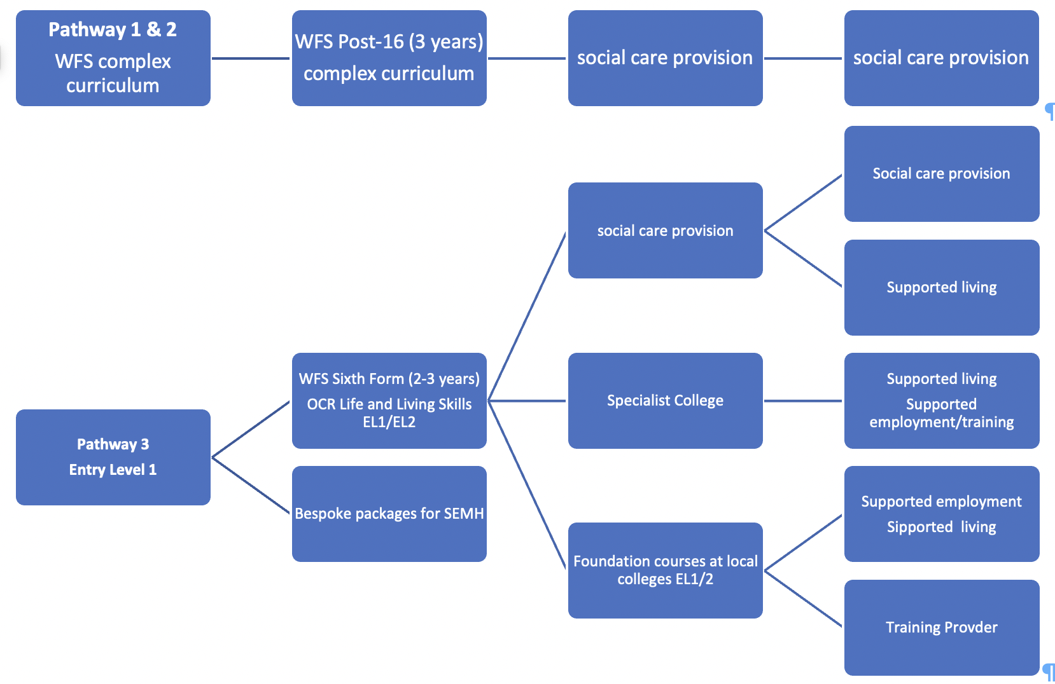
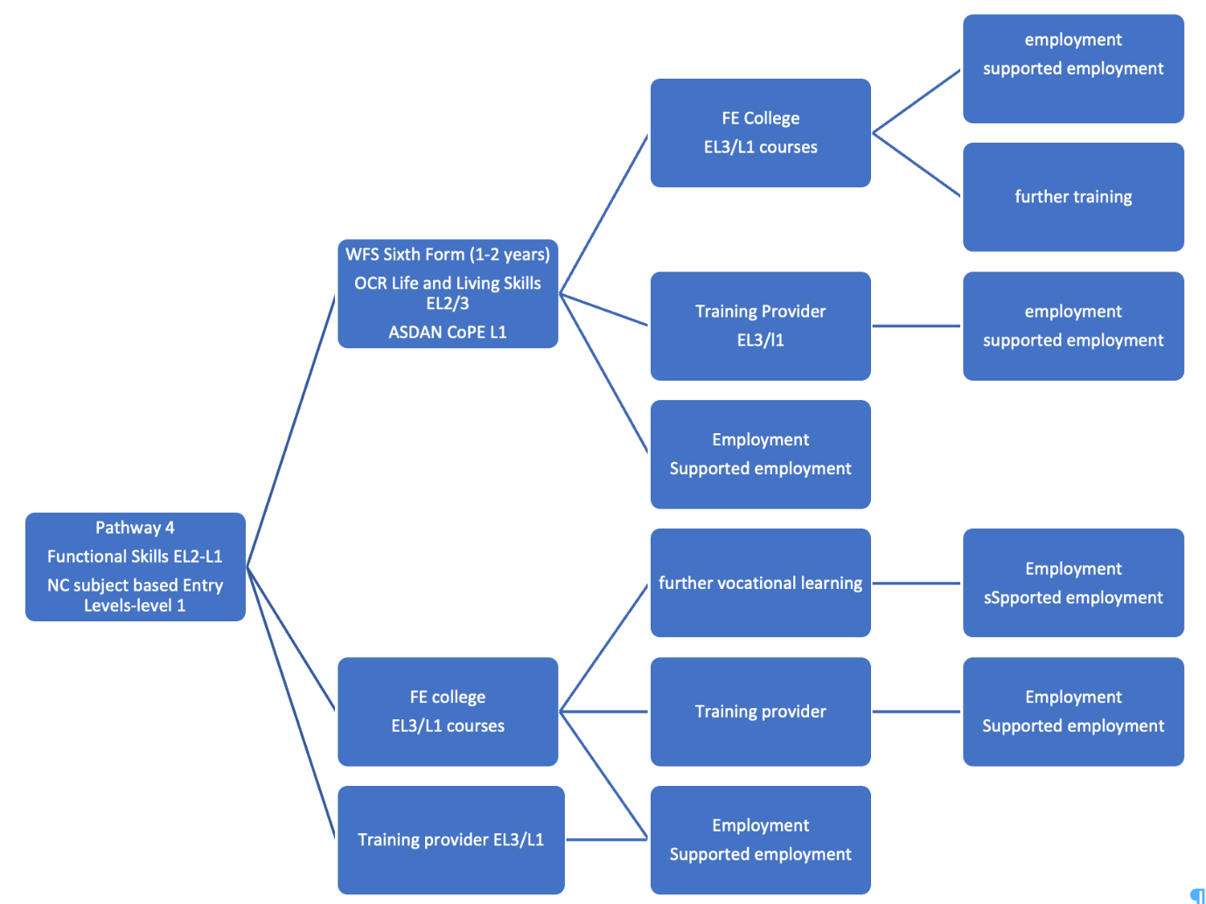

Russell House (Residential)

Russell House as an integral part of Wyre Forest School; policy and practice are through a shared approach. The curriculum for the residents allows there to be a twenty-four-hour offer, with both the home and day school setting using a shared curriculum (WFS Progression Steps) and shared approaches to support each child’s preferred mode of communication and behaviour/emotional management strategies.

Residents attend Russell House for a variety of reasons. A thorough placement plan is carried out to ensure individual resident objectives are set. Staff at Russell House and at WFS day school collaborate to support the holistic development of the pupils.

Intent:
At Russell House it is our intent to customise an individual set of targets for our young people to work towards, focusing mainly on three key areas of development which are: independent living skills, social and emotional development and physical/mental health and well-being. We endeavour to identify need and work in close conjunction with school staff and parents to allow progress to be tracked and celebrated.
The secure environment at Russell House provides a perfect platform for our young people to strive towards achievable goals that will enhance day to day life and transition into adulthood.

Implementation:
Our young people at Russell House are challenged daily by staff to encourage all areas of development. Targets are set by key workers and teachers at regular Team Around the Child (TAC) meetings and link with targets set in school, outlined in the WFS Progression Steps. Students attend the TAC meetings (where appropriate) to add their own voice to the review and the setting of new targets. Within the residential setting there is opportunity to access community-based activities and to carry out independent living tasks allowing skills that are taught in school to be transferred to daily life with support and encouragement from staff.
Evidence is observed and recorded with photo, video or written confirmation and shared with school and parents. Student “wow moments" are also captured to celebrate incidental progress, something that the pupil may have done for the first time or just something the pupil has done without any input from an adult e.g. support another child in using their communication aid to request more breakfast!

Impact:
Staff at Russell House will always motivate our young people and provide them with opportunities to achieve and thrive. Residents achieve the target set at the TAC meetings and this progress is seen at home. Where this is the case, we encourage parents to share evidence of this through the Evidence for Learning.
Staff will evaluate progress from all evidence gathered and share with students themselves giving them the opportunity to discuss their achievements and consider next steps.

Wyre Forest School Approach to Speech, Language & Communication
Intent:
At WFS we believe that all pupils have a voice and the entitlement to communicate; to be able to say no, share their thoughts, wants and needs and to be responded to in an appropriate and meaningful way. Communication development is therefore embedded into all aspects of the curriculum, through the four communication standards and we continue to up-skill staff to be able to respond to all leaners. Staff at WFS understand the building blocks required for language development and how language develops (see Typical Language Development table below) and use this knowledge to support pupils’ development, not only in communication but other aspects of learning such as play.
Typical Language Development
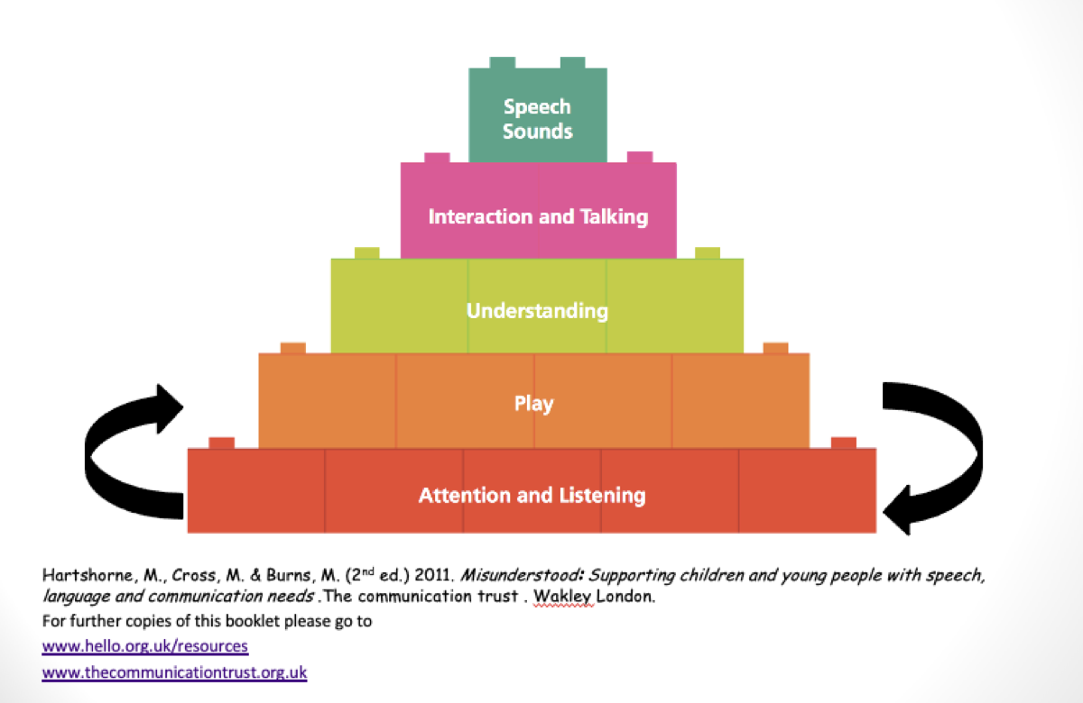
Implementation:
Each pupils’ level of communication is assessed using the WFS Communication and Interaction Progression Guidance, which is part of the wider WFSPS. Class teams are supported by the WFS Communication Team and the Speech and Language Therapy Service so that the most appropriate approach is used and communication opportunities can be maximised. The Communication Team and teachers, often also work with parents/carers so that the same approaches can be used at home to support understanding and often emotional/behaviour management.
Class teams, particularly those with learners in pathways 1 &2 will consider the means, reasons and opportunities models (See Means, Reasons & Opportunities information below) for each learner to plan how to best meet need and provide meaningful opportunities for communication and engagement.
Means, Reasons & Opportunities Model
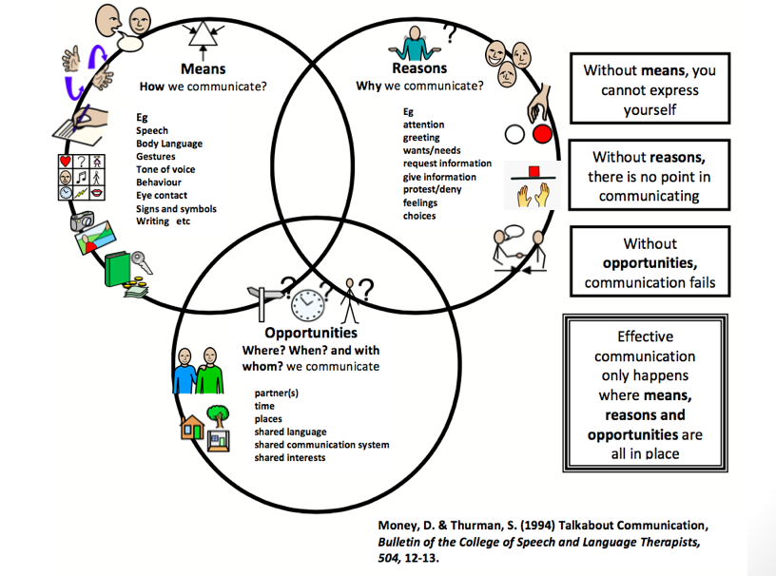
Observations against the individual pupils’ speaking and listening targets will be continually recorded on EfL and progress assessed to determine next steps. This may also include contributions from parents. This data will be discussed throughout class meetings and during pupil discussion meetings. Where required the Communication Team will provide training to staff on the use of augmentative and alternative communication (AAC) such as signing, aided language displays (ALDs), communication books, picture exchange (PECs), and support the implementation and use of voice output communication aids (VOCAs).
Impact:
Evidence of progress will be seen on EfL, through parent feedback during annual reviews and parent evenings and on Speech & Language Therapy reports.
Wyre Forest School Approach to Reading
Intent:
The ability to read is fundamental to many aspects of life and is central to general progress and developing an understanding in a wide range of areas of the curriculum. The teaching of reading is to be given a high priority by all staff. Reading develops pupils’ imagination, experiences and supports conceptual learning. It is our aim that, by the end of their Wyre Forest education, pupils are able to read to a functional level with increasing fluency so that they can access the world around them with increasingly growing confidence and skill. ​We intend to achieve this whilst ensuring that the provision takes into account the uniqueness and complexity of our learners.
For pupils with additional needs, reading may be interpreted as any activity that leads to the derivation of meaning from visual or tactile representation, for example objects, pictures, symbols or written words. They may be accessed visually, aurally or through touch.
Our reading strategy also demonstrates the inextricable link we recognise between reading and communication - Words have meaning, power and consequences and language provides the connective tissue to help connect people (when used well). All staff are trained in and used a total communication approach to learning.
Our Intent is to:
To promote high expectations of learning in reading, we aim to ensure that pupils:
- are provided with a language-rich learning environment, that supports every level of reading.
- are given opportunities to engage/access books, sensory stories and sensory objects to encourage their interest in books.
- choose and peruse books /sensory objects relating to a story freely as well as sharing them when read by an adult.
- to show their preference for books, stories and objects via their preferred method of communication.
- enjoying and sharing books /sensory props, to see them as a source of pleasure. The aim is to spark interest and motivate them to enjoy reading.
- are prepared for learning to read through developing symbolic representation, this can be from starting with objects of reference, to understanding photographs as representations of objects then to understanding symbols such as those used in Widgit; then to letters and words.
- read with increasing fluency and understanding; their working memory is increasingly able to focus on comprehension and conceptual understanding.
- develop the habit of reading often, for both pleasure and information
- acquire a wide vocabulary, an understanding of grammar and knowledge of linguistic conventions for reading, writing and spoken language.
- write with increasing clarity and coherence to meet the demands of a language rich world.
- use communication in order to learn; and to express their needs and wants.
- are growing competent in the skills of communication, asking and responding to questions and participating in discussions, demonstrating an understanding of what they have read.
- develop and address their reading skills within all areas of their curriculum provision and learning beyond the classroom as class staff use their knowledge of pupils to ensure this happens. This will ensure we achieve fluency and competency of reading skills as it is embedded in long term memory.
Implementation:
Pupils will learn to read with a specific focus on phonics through Read Write Inc. Staff will also recognise how the other strands within English will support learning in reading as well as its role within all subject curriculum documents.
Pupils will:
- experience a total communication learning environment through use of strategies and aids such as PECS, VOCA, Widgit and Signalong.
- begin their reading journey when assessed as ‘ready’ by staff. A pupil’s readiness will be recognised as being able to maintain concentration and attention, displays positive dispositions and attitudes to learning and engages with environmental sounds
- begin to access phonics through the Wyre Forest Communication, Literacy and Language Phonics (CLLP) programme. Staff will engage pupils and develop their communication and language skills through singing songs, nursery rhymes and playing games
- complete a baseline assessment in phonics, using the Read Write Inc assessment to inform their starting point and from which progress can be tracked.
- work through Read Write Inc synthetic phonics programme and this is delivered systematically across the Pathways where it is relevant and appropriate at individual level.
- read books which follow the delivered sounds of Read Write Inc and balance this with reading books which develop their understanding and vocabulary development at the appropriate level.
- encounter staff sharing a love of reading and also reading aloud to them in a way that excites and engages them, introducing new ideas, concepts and vocabulary.
- have regular reading sessions, that focus on impacting on learning in reading. This could be in the form of phonics, reading, comprehension vocabulary development.

Reading Development at Wyre Forest School

Impact:
Pupils read frequently to access information and for enjoyment and this is celebrated, encouraged and modelled by school adults. Pupil progress and attainment is measured through:
- WFS Progression Steps
- WFS CLLP
- Book band levels
- Phonics Phase
This provides a very rounded and informative picture of how our pupils progress in their reading skills.
Pupil achievement in the end of Year 11 outcomes, Functional Literacy and NCFE Entry Level Certificate in English (where appropriate) also provides a measure of the impact in Reading. Pupils are also well prepared for their transition to a post 16 provision and preparation for life after Wyre Forest School.
Each pupil’s learning in Reading is led by informed target setting to ensure expectations are high and they are reading at a level appropriate to their needs, age and ability.
How will we ensure all pupils are making progress in reading?
The synthetic phonetic approach may not enable all pupils to learn to read and these pupils will have access to other methods of learning reading. Pupils will be continually assessed by staff to ensure that they are ‘ready’ and will begin the Wyre Forest Communication, Language and Literacy Phonics programme. When it is assessed and decided that a pupil needs a different approach, there are a range of approaches they could access, dependant on age and need:
- That Reading Thing- for older pupils who continue to require phonics.
- See and Learn Language and Reading- for pupils who learn and develop their reading skills using sight words
- Nessy Reading and Spelling- for pupils who have dyslexic traits or those who require more support when blending sounds.

Wyre Forest School Approach to Writing
The WFSPS support the key steps in developing early writing, from the pupils enjoying the sensory experience of mark making, through having their marks valued to writing their own name. Opportunities for sensory exploration of making marks and making marks with symbolism through role play is highly valued and embedded in classrooms across the early pathways. Then when the pupils begin RWI phonics, they are taught the correct letter formations. This begins with writing (whether with a writing tool or in the air) cvc words, moving onto short sentences using the sounds they have been taught. Pupils are encouraged to write independently during the continuous provision offer and within planned activities. R.W.I Reading into writing activities include;
• ‘Hold a sentence’ which encourages the children to remember a whole sentence while focusing on spelling and punctuation
• ‘Build a sentence’ which gives the children the opportunity to create their own sentence to that shows the meaning of a word
• ‘Edit a sentence’ which allows the children to critique a sentence using their knowledge of spelling, punctuation and grammar.
Children then complete a longer piece of independent writing, which gives them the opportunity to show off their creativity and to practice their spelling, grammar and punctuation.
Wyre Forest School Approach to Numeracy
Maths at WFS is planned sequentially from the WFS Progression Steps into the National Curriculum. Teachers plan the learning forward from each child’s individual starting point. Activities will be planned, as far as possible using practical and real-life scenarios to support understanding. Where there are gaps in learning or confusion around key concepts, teachers will try a range of methods to support understanding.
Students in Post 14 & 16 classes will continue to develop their understanding of mathematics, whether this be through accreditation or developing real-life understanding through shopping, reading bus timetables and weighing ingredients. Teachers will plan the learning to enable the students to become as independent as possible in their life beyond WFS.

Wyre Forest School Approach to the National Curriculum subjects; Science & the Foundation Subjects
Pupils in Pathway 4 and those in Pathway 3 who are ready to access National Curriculum Year 1 expectations, in any given subject, will then follow this curriculum. It may be that a Pathway 3 child is working from the maths National Curriculum and the WFS Progression Steps in other areas of learning. The WFS Progression Steps provide skills, knowledge and understanding towards the subject areas to prepare the pupils for this and ensure that teachers are confident of continued progression and success.
Curriculum leaders (WFSPS curriculum areas, including English and Maths) can provide support to staff with planning and their approach to the curriculum, whilst ensuring their subject is represented accurately and appropriately across the school. Subject specialist teachers also offer guidance for planning.
Wyre Forest School Approach to PSHE (Personal, Social, Health & Economic Education)
At WFS we want our learners to go on to live happy, safe and successful lives in their wider communities. We want them to leave our school as rounded young adults, ready to meet the next phase in their lives, whatever that may be. We also recognise that many of our pupils are vulnerable and will need support in engaging in and developing an understanding of learning experiences within the wider world.
The aims of our Personal, Social, Health & Economic (PSHE) curriculum is to support our young people to:
- be able to communicate and interact effectively with others.
- become more resilient and confident individuals.
- become as independent as they can within their daily lives and life beyond Wyre Forest School
- understand their bodies and emotions and how to promote their physical and mental wellbeing.
- form and sustain positive, healthy relationships and to recognise when a relationship is not healthy and where they can seek support.
- develop pupils’ understanding of their own and others’ mental health and well-being.
- understand their own place in the world and develop a tolerance of those who make different life-style choices to their own.
- develop an understanding of risk, whilst still making safe and informed decisions.
Teachers plan the PSHE curriculum with a sequential and spiral approach to ensure coverage and repetition to aid understanding. Dependent on pupils working levels, the curriculum is planned from the WFS Progression Steps areas of;
- Independence
- Mental Health & Wellbeing
- Physical Wellbeing and Development
and the following areas:
- Positive Communication
- Healthy Growth and Wellbeing
- Safe Relationships
Relationships and sex education (RSE) is an important part of PSHE education. Relationships education is compulsory for all primary school pupils, and Relationships and Sex Education (RSE) is compulsory for all secondary school pupils.
There are natural links with our Careers and Preparation for Adulthood and Religious Education programmes and delivery content from our Online Safety Policy.
Careers & Preparation for Adulthood
At Wyre Forest School our careers programme is tailored to meet the needs of learner groups and individuals from Year 7 onwards across all pathways. Our programme consists of learning, advice and experiences across:
- Careers
- The World of Work
- Enterprise
- Life Skills
- Transition into Adulthood
In December 2017, the DfE produced a Careers Strategy: Making the most of everyone’s skills and talents. The document lays out plans to raise the quality of careers provision nationally. The Gatsby Benchmarks are the measure of excellence in careers provision.

Gatsby Benchmarks:
- A stable careers programme
- Learning from career and labour market information
- Addressing the needs of each student
- Linking curriculum learning to careers
- Encounters with employers and employees
- Experiences of workplaces
- Encounters with further and higher education
- Personal Guidance
At WFS we are committed to supporting the transition into adulthood of all our learners through fulfilling the aims of the DfE strategy alongside meeting the diverse needs of our young people.

Careers and Transition Advice
At WFS our Careers and Transitions Advisor (CTA) provides impartial careers and transition support to students and their parents.
Year group | Planned Input
Year 7 | Group session - Introducing the CTA & PfA  Individual meetings/support for students if necessary |  |  | CTA appointments available at parents evenings.  CTA available for informal discussion with students and parents at Life Beyond School Event (Spring Term)
Year 8
Year 9 | Group session as above.  1:1 discussion with each pupil and their parents/carers. Transition action plan document produced in readiness for the Preparing for Adulthood ECHP review.
Year 10 | Group session as appropriate  1:1 discussion with each pupil and their parents/carers. Transition action plan document produced in readiness for the Preparing for Adulthood ECHP review. |  | CTA updates transition plan and provides support in readiness for the Preparing for Adulthood Annual Review of EHCP.
Year 11 | Group session as appropriate  1:1 discussion with each pupil and their parents/carers and support available for applications.  CTA available for further support with decision making, transition, etc.
Year 12 | Throughout their time in sixth form, CTA will be in regular contact with pupils, identifying and responding to any changing aspirations.  Group session as appropriate  1:1 discussion with each pupil and their parents/carers and support available for applications. | CTA available for discussion with parents and students at coffee mornings.
Year 13
Year 14
Wyre Forest School Approach to Relationships Education & Relationships & Sex Education (RSE)
It is a statutory requirement to teach relationships education; Relationships Education for primary age pupils and Relationships and Sex Education (RSE) for all secondary school pupils. RSE sets scientific knowledge within a broader context and gradually and progressively explores relationships, emotions, views and the promotion of our physical and mental wellbeing. It links to other areas of personal development such as the wider PSHCE curriculum, online safety, science and religious education (differing views, beliefs and practices).
As with all aspects of learning at Wyre Forest School, pupils are introduced to key learning at an appropriate cognitive and emotional level. The approach to this will always be sensitive and respectful and parents and carers are informed before key learning is shared. Staff will endeavour to cover as much of the statutory requirements as appropriate, ensuring that teaching is differentiated and personalised. The WFS Progression Steps support earlier understanding that can be built upon.
RSE may be delivered formally to whole groups, small groups or on an individual basis according to the needs of pupils. Work will be adapted to the understanding of the pupils and supported with appropriate methods of communication and resources. At times conversations with pupils, parents or carers, or school staff noticing particular behaviours may indicate the need to develop a pupil’s knowledge in regard to a specific issue. This additional support may take place within RSE lessons or on a more informal basis either individually, in a small group or within the class group as appropriate so as to ensure the needs of each pupil are met.
Where pupils ask genuine questions pertaining to sex or sexuality which go beyond those set out for RSE or Relationships Education (where sex education is not taught), adults may answer them in sensitive and appropriate ways accessible to that pupil.
Parents/Carers who opt to withdraw their child from RSE lessons will be invited to discuss any concerns with the RSE subject specialist. Support is always available to parents and carers to help them discuss the RSE content with their child.
WFS approach to teaching gender and sexuality
Pupils at WFS are supported, within an open and honest environment, to develop their own identity of which gender and sexuality is only a small part. Gender and sexuality are taught explicitly across the developing curriculum, starting within the WFPS and continuing into pathway 4 and post-14/16 RSE curriculum. Questions posed by pupils outside of these planned lessons are approached in a mindful manner, considering the needs and developmental levels of the individual and the class group. If the question aids understanding for the
whole class group within the context of the lesson, it may be appropriate to consider this an opportunity to teach about gender and/or sexuality. Otherwise, the question will be acknowledged and responded to in a timely manner or directed to pupil pop-in.
In sixth form, pupils have the option to join Harmony. This is our LGBTQ+ allies group led by Rosie Hopkins (Sixth Form Teacher) who is trained in supporting LGBTQ+ children and young people. Where pupils lower down the school have ask questions, they may access the Harmony group for support.

Wyre Forest School Approach to Religious Education (RE)
At WFS we follow the Worcestershire Agreed Syllabus 2020-2025 that has the vision that all pupils, including those with special educational needs and disabilities (SEND) can benefit from religious education (RE). The law states that the agreed syllabus is to be taught to SEND pupils ‘as far as it is practicable’.
We adhere to Worcestershire’s advice, regarding RE in special schools; drawing on the key ideas of ‘discovering, exploring, connecting and responding’. Within planning teachers embed the following approach to enable them to use the religious themes and concepts as a source of information and then plan RE so that pupils can explore and respond, at the same time promoting their own personal development by making connections with core religious concepts and their own experiences.
- Connection – what links can we make with our pupils’ lives? Creating a bridge between pupils’ experiences and the religious theme.
- Knowledge – what is the burning core of the faith? Selecting what really matters in a religious theme, cutting out peripheral information.
- Senses – what sensory elements are in the religion? Looking for a range of authentic sensory experiences that link with the theme.
- Symbols – what are the symbols that are most accessible? Choosing symbols that will encapsulate the theme.
- Values – what are the values in the religion that speak to us? Making links between the values of the religious theme and the children’s lives.
Teachers tailor planning of RE experiences supported by links to other areas of the WFS progression Steps and the Personal Social Health & Economic curriculum (PSHE) curriculum. This will include pupils’ understanding of

- their own individuality.
- finding their own calm and space in the world.
- the use of multi-sensory approaches.
- finding insights into being able to answer tough questions.
Within each pathway, but not restricted only to that pathway, the RE provision may include:

Pathway 1 & 2 - Supporting the pupils in
- finding their own individual approach to life
- finding times of calm
- developing an awareness of themselves, their feelings, their emotions & their senses.

Pathway 3 - Developing the pupils’
- multi-sensory approaches to introduce spiritual experiences
- social development through story, music, shared experience, and ritual
- relationships with other people and their understanding of other peoples’ needs

Pathway 4 – Providing
- an insight into the work of religion and human experiences, through questioning
- opportunities for pupils to partake in spiritual or reflective activity
- opportunities to enable pupils to make links with their own lives
Wyre Forest School Approach to Physical Development & PE (Physical Education)
Planning for physical development, uses steps within the WFS Progression Steps, building up to National Curriculum expectations and as part of accreditation in Post 14 classes. Teachers working with learners within National Curriculum levels are supported with use of the REAL PE programme.
Pupils with physical needs highlighted on their EHCP or through external agencies will be supported with programmes created by physio therapists and/or occupational therapists. Staff at school work closely with the external experts to ensure that the pupils can either reach their full potential in this area or are supported to be more comfortable within their physicality. Staff are trained, to enable the programmes to become embedded within the pupils’ daily/weekly curriculum. At any point staff or parents and carers can refer their child for further support.
Wyre Forest School Approach to Play
At WFS, we recognise that play underpins learning and may aspects of children’s development. Through play, children develop language skills, their emotions and creativity, social and independence skills. For most children their paly is natural and spontaneous, however many children at WFS will need a planned approach to support this development. At WFS, play takes place indoors and outdoors where the pupils can explore and discover their immediate world, practise new ideas and skills, take risks and solve problems on their own or with others. The role that the adults play is crucial. For this reason, we ensure our staff are trained in recognising and planning to develop the different levels of play in all our pupils. We ensure that we support the development of play in safe but challenging environments, whatever pathway the pupil may be in.
Wyre Forest School Approach to Outdoor Learning
Outdoor Learning is a broad term that includes discovery, experimentation, learning about and connecting to the natural world, engaging in environmental and adventure activities. At WFS we recognise the value of our pupils experiencing the outdoor world, whether it be the sun or wind on their faces, growing a vegetable that they can cook and eat or recognising the local outdoor opportunities available to them in their own communities. We recognise a continuum of development in this area and each pathway will follow an approach that best suits their needs and abilities. Evidence of progress against the key skills will be collated using the Outdoor Learning WFS Progression Steps or a relevant award - John Muir, RSPB.

Outdoor Learning Continuum

Pathway | Outdoor Learning Opportunities
Early Years, Pathway 1 & 2 | Outdoor Play
Pathway 3 | Forest School
Pathway 4 | Land based studies
Post 14 | John Muir (Pathway 4)  RSPB/John Muir Award (Pathway 3)  Outdoor Play (Pathway 1 & 2)
Post 16 | Allotment (on-site & at Bishops Wood)

