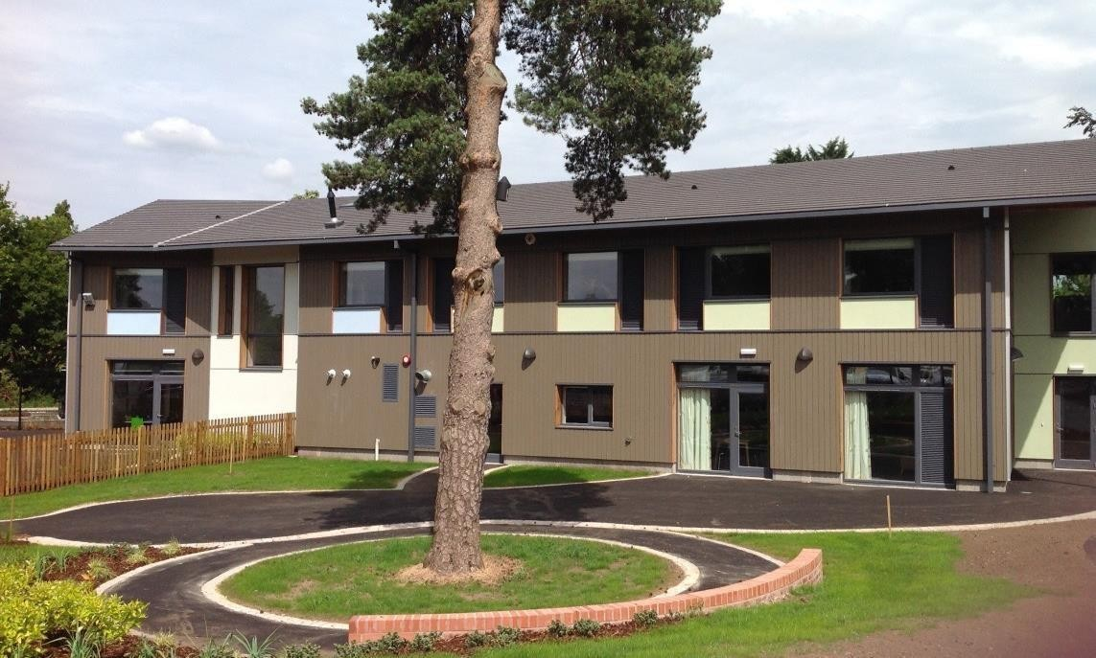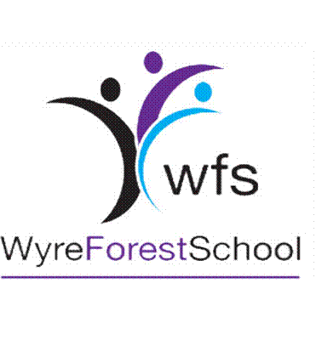

Russell

House

Statement

of

Purpose

and

Function

Date of last review: | September 2026 | Review period: | Annual
Date of next review: | September 2027 | Written by: | Carla Mole

Our School, Our Vision and Our Values

Wyre Forest School is a Local Authority Maintained Generic Special School located in North Worcestershire. The school caters for pupils aged 3-19 years.
All pupils have an Education Health Care Plan, unless being assessed within the Nursery Assessment Class.

Our vision is to truly ensure that we meet the individual needs of all children at WFS and prepare them for adulthood.

We Foster Success by providing a safe, happy environment in which all pupils can develop and achieve!
Our Values at Wyre Forest School are:
Enthusiasm
Resilience
Honesty
Teamwork
Trust

Our purpose-built residential facility, Russell House, caters for a maximum of 16 pupils and opens Monday to Friday term time only.

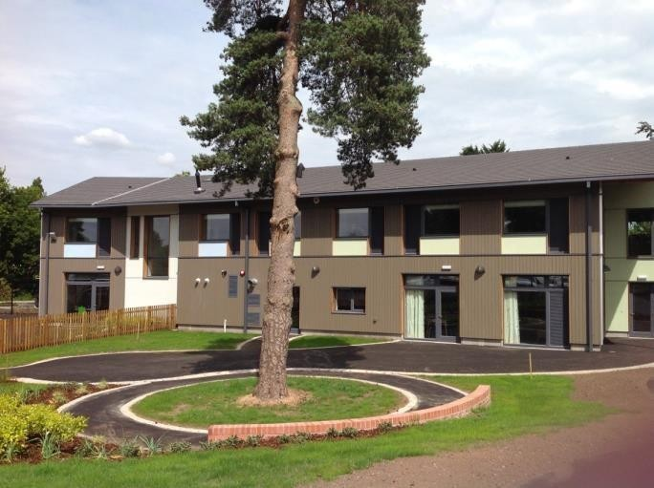

Termly Boarding
The Wyre Forest School Educational Boarding Provision, Russell House, is a facility that provides care from Monday after school until Friday morning before school.

The provision is offered to students who are already placed at Wyre Forest School and have met our admissions requirements (see Admissions Policy).

Our Purpose
Here at Russell House we uphold the values of Wyre Forest School, and , thus, support each young person to flourish in becoming independent individuals that reach their full potential in life.

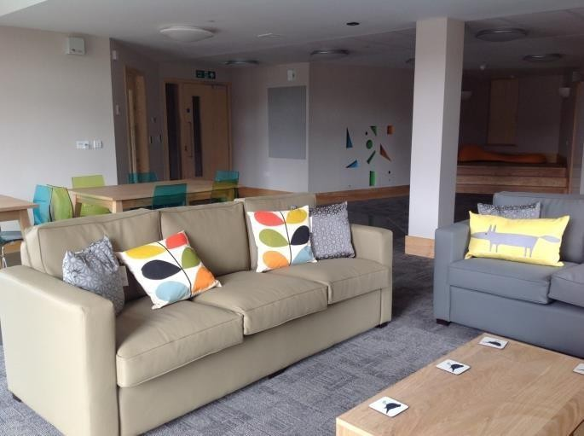

When I am at Russell House, wherever I am, whoever I am with, whatever I am doing, I have these fundamental rights:
to be valued as an individual
to be treated with dignity and respect
to be loved and cared for as a person first
to be safe to be healthy
to enjoy and achieve
to make a positive contribution
to achieve economic wellbeing.

Our Function

Here at Russell House staff work alongside the young people, parents and class teams to support a 24 hour curriculum focusing on our three target areas; Mental health and wellbeing, independence and communication.

Pupils are allocated key workers which enables all students to develop strong, trusting relationships with others. Allocated staff monitor progression, target areas and liaise with parents on a regular basis.

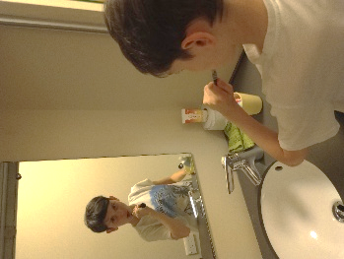
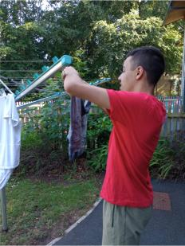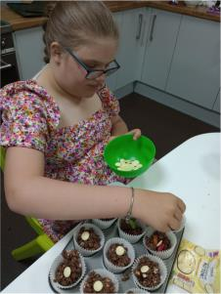

Residential Staff Structure
The structure of staffing within the school and boarding provision consists of:
Governors: Brenda Lines and Krys Malpass
Head Teacher: Rebecca Garratt

Senior Deputy Head Teacher: Jo Kehoe Deputy Head Teacher: Alison Hopkins

Assistant Head: Rebekah Thompson, Laura Morris, Aimee Pearce

Head of Care: Carla Mole
Care Officers : Jemma Mole, Abby Davies, Freja Jones, Nick Sankey, Lucie Crawford
Waking Night Staff: Helen Davies, Laura Ashfield, Julie Hinton, Laura Cooper
Care Assistants: Steve Bingham, Dene Claridge, Katie Mai-Morris

All staff in Russell House are qualified sufficiently for the post that they are in or working towards the relevant qualification in care (QCF Level 3 or equivalent in Children and Young People).

The Accommodation
Russell House is divided into two adjoining wings that all students can freely move between, each wing briefly comprising of:
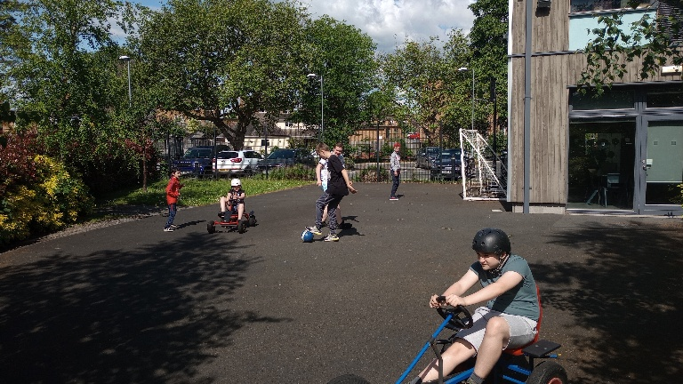
- A large open-plan lounge and dining area which consists of adequate seating around a large dining table, comfortable seating around the TV area, a small raised calm/sensory space and doors out onto the landscaped gardens. In one of the wings, there is an addition of a kitchenette for the students to be a more independent in the preparation of breakfast and light meals/snacks.

- Calm room / Play Room / Gaming Room leading off the lounge which can be used for a quiet space, individual play, gaming area or as a chill-out zone. This also leads out onto the garden area. One of these areas is currently laid out as a calm space with low level seating and bean bags whilst the other room houses our gaming equipment (X-box Nintendo Switch and WiiU) which our students can access as a reward or choice activity.

- Downstairs toilet leading off the lounges.
- Sixteen Bedrooms (upstairs) of which, Fortine have en-suite shower, toilet, wash facilities. Each bedroom has; a large desk space with a chair, single bed and bedside table, a large built-in wardrobe. Each room can be personalised with posters, pictures, etc. One bedroom does not have an en-suite, however has its own wash facilities is located beside the house bathroom.
Each bedroom is colour coded based on fire evacuation procedure. Any pupil coded RED would be located in the downstairs bedroom.
- Two separate bathroom (upstairs) for students wishing to have a bath instead of a shower.
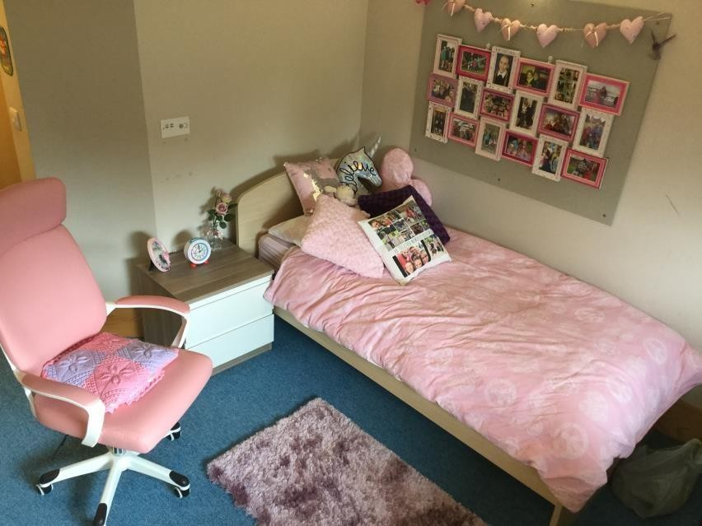
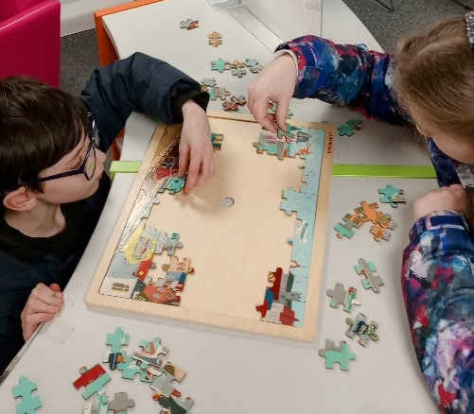
Further Shared Accommodation across the two corridors, comprises of:
A large activity Room for art/craft area and flexible space for many activities including more messy play. There is a telephone corner with low level seating for students to relax and call home when they wish. Students freely access the gardens from this room and art/craft is often taken outside if the weather permits.
- A Cinema/Sensory Room/Soft Play were students can relax in peace and quiet and can react to interactive lighting and soft music. There is soft seating area which can also double up as a Soft Play Zone. This room also functions as a cinema room with a large screen projected on to one of the walls with fitted speakers in the ceiling.
- The Main kitchen which has been designed and furnished as a homely kitchen with all the practicalities required to prepare food.
- The large laundry facility which comprises; washing and drying machines and large airing cupboards and storage.
- A lift between the floors is situated between the two corridors and can be used for students and visitors who need additional mobility support.
In addition, there are two staff sleep-in rooms, each with en-suite and work area, etc. A waking night staff member can contact staff using a pager/alarm system or internal phone/radio should the need arise. Waking night staff base themselves in the large lounge, and complete hourly checks throughout the night.
The staff office which is well equipped and sufficiently spacious, is located by the main entrance, lobby.
The building itself, has been designed to be as fuel efficient as possible, thus reducing energy costs and promoting a “green” ethos and focus. This continues throughout the provision with economical, energy saving ideas incorporated in many areas.
Furnishings and fittings are to a high standard and maintain a modern, homely feel with bright varied colouring. Large windows give a great deal of light and look out on to private gardens. Security within the building can be altered dependent on the needs of the individual students.

